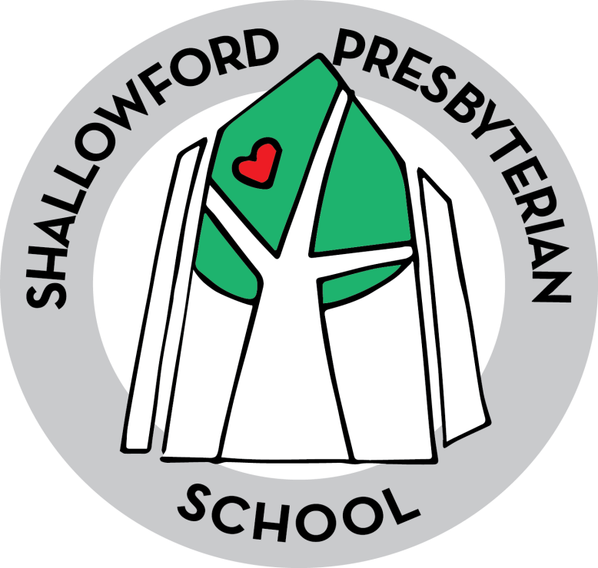

Shallowford Presbyterian School
Curriculum

At SPS our mission is to nurture the whole child by accepting uniqueness and developing an academic, spiritual, and social foundation.
Shallowford Presbyterian School offers a challenging, balanced curriculum that encourages exploration and discovery. Our classrooms are student- centered and focused on developing critical thinking skills. Our small class sizes allow our teachers to customize instruction in order to meet diverse needs of our learners. We believe that every child is unique, which is why SPS believes in nurturing the whole child physically, emotionally, socially, cognitively, and spiritually.

Kindergarten
Language Arts/Reading:
Students at SPS work in small groups using the workshop model. Students focus on phonics, handwriting, spelling, creative writing, comprehension, and vocabulary.
Students use:
Units of Study for Primary Writing by Lucy Calkins
Each student is assessed using the Developmental Reading System (DRA) at the beginning, middle, and end of the year. This allows parents and teachers to have a clear picture of each student’s strengths and instructional needs.
Students use:
Wilson Fundations
Wilson Fundations for K-3 is a phonological/phonemic awareness, phonics and spelling program for the general education classroom. Fundations is based upon the Wilson Reading System® principles and serves as a prevention program to help reduce reading and spelling failure.
Teachers incorporate a 30-minute daily Fundations lesson into their language arts classroom instruction. Fundations lessons focus on carefully sequenced skills that include print knowledge, alphabet awareness, phonological awareness, phonemic awareness, decoding, vocabulary, fluency, and spelling. Critical thinking, speaking and listening skills are practiced during Storytime activities.
http://www.fundations.com/
In addition to the handwriting component of Fundations, students use Handwriting without Tears, published by Jan Olsen. Kindergarten students work on the correct formation of capital letters as well as an introduction to lower case letters.

Math:
Students use hands on manipulatives to explore addition and subtraction concepts, place value, measurement, and geometric shapes.
Students use Everyday Math, published by McGraw Hill. Throughout the series students will develop their math skills by building on the concepts they have learned.

Science and Social Studies:
Science and Social Studies concepts are integrated throughout our Math and Language Arts units of study.
In Science, Kindergarten students learn through exploration and discovery. They observe the world around them and make predictions based on their observations. Students learn through questioning and develop comparisons about the world around them by using their five senses.
In Kindergarten, Social Studies, students begin to understand the foundations of History, Geography, Economics, and Government. Students learn about the world around them and how they fit into that world. They also learn what it means to be a good citizen.

First Grade
Language Arts/Reading:
Students at SPS work in small groups using the workshop model. Students focus on phonics, handwriting, spelling, creative writing, comprehension, and vocabulary.
Students use:
Units of Study for Primary Writing by Lucy Calkins
Each student is assessed using the Developmental Reading System (DRA) at the beginning, middle, and end of the year. This allows parents and teachers to have a clear picture of each student’s strengths and instructional needs.
Wilson Fundations
Wilson Fundations for K-3 is a phonological/phonemic awareness, phonics and spelling program for the general education classroom. Fundations is based upon the Wilson Reading System® principles and serves as a prevention program to help reduce reading and spelling failure.
Teachers incorporate a 30-minute daily Fundations lesson into their language arts classroom instruction. Fundations lessons focus on carefully sequenced skills that include print knowledge, alphabet awareness, phonological awareness, phonemic awareness, decoding, vocabulary, fluency, and spelling. Critical thinking, speaking, and listening skills are practiced during Storytime activities.
Math:
Students use hands on manipulatives to explore addition and subtraction concepts, place value, measurement, and geometric shapes.
Students use Everyday Math, published by McGraw Hill. Throughout the series students develop their math skills by building on the concepts they have learned.
Science and Social Studies:
Science and Social Studies concepts are integrated throughout our Math and Language Arts units of study.
In Science, students learn to explore the world through questioning and seek answers through observation. Students are introduced to beginning concepts of Earth, Life, and Physical Science.
The Social Studies curriculum focuses on an introduction to American History. Using primary sources (www.gallopade.com/), students learn about important historical figures. Students also explore basic concepts of Geography.

Second Grade
Language Arts/Reading:
Students at SPS work in small groups using the workshop model. Students focus on phonics, handwriting, spelling, creative writing, comprehension, and vocabulary.
Students use:
Units of Study for Primary Writing by Lucy Calkins
Wilson Fundations
Wilson Fundations for K-3 is a phonological/phonemic awareness, phonics, and spelling program for the general education classroom. Fundations is based upon the Wilson Reading System® principles and serves as a prevention program to help reduce reading and spelling failure.
Teachers incorporate a 30-minute daily Fundations lesson into their language arts classroom instruction. Fundations lessons focus on carefully sequenced skills that include print knowledge, alphabet awareness, phonological awareness, phonemic awareness, decoding, vocabulary, fluency, and spelling. Critical thinking, speaking and listening skills are practiced during Storytime activities.
Math:
Students use hands on manipulatives to explore addition and subtraction concepts, place value, measurement, and geometric shapes.
Students use Everyday Math, published by McGraw Hill. Throughout the series students develop their math skills by building on the concepts they have learned.
Science and Social Studies:
Science and Social Studies concepts are integrated throughout our Math and Language Arts units of study.
In Science, students continue to explore the world through questioning and seek answers through observation. Students begin to use fractions, sums, and differences to find answers. Students estimate lengths, weights, and time. Science focuses on changes in the world around us.
In second grade, students focus on Georgia History. They learn about the Creek and Cherokee cultures, Georgia geography, and historical figures. Students learn basic concepts of government and basic economic concepts. Students use activities from www.gallopade.com.

Third Grade
Language Arts/Reading:
Students at SPS work in small groups using the workshop model. Students focus on phonics, handwriting, spelling, creative writing, comprehension, and vocabulary.
Students use:
Units of Study for Primary Writing by Lucy Calkins
Wilson Fundations
Wilson Fundations for K-3 is a phonological/phonemic awareness, phonics, and spelling program for the general education classroom. Fundations is based upon the Wilson Reading System® principles and serves as a prevention program to help reduce reading and spelling failure.
Teachers incorporate a 30-minute daily Fundations lesson into their language arts classroom instruction. Fundations lessons focus on carefully sequenced skills that include print knowledge, alphabet awareness, phonological awareness, phonemic awareness, decoding, vocabulary, fluency, and spelling. Critical thinking, speaking and listening skills are practiced during Storytime activities.
Math:
Students use hands on manipulatives to explore multiplication and division concepts, fractions, rectangular arrays, area, and two dimensional shapes.
Students use Everyday Math, published by McGraw Hill. Throughout the series students develop their math skills by building on the concepts they have learned.
Science and Social Studies:
Third grade students expand their knowledge of Earth, Physical, and Life sciences. Science units focus on observations, calculations, and data collection to form an understanding of how things work together and impact each other.
The Social Studies curriculum focuses on the origins of American Democracy. Students explore ancient governments and develop an understanding of America’s political roots. Students also examine rights and freedoms in America and learn about those who helped achieve those rights. Students analyze basic topographical features of the United States and learn about services provided by governments.

Fourth Grade
Language Arts/Reading:
Students expand and deepen their knowledge of reading, writing, and speaking, as well as their understanding of the connections among different types of communication. Fourth grade students read and comprehend texts from a variety of genres (fiction, nonfiction, poetry, and drama), and they can understand and learn from texts without having a teacher preview the material for them. Students also read and understand informational texts from other subject areas in addition to language arts. As they read, students in the fourth grade independently use a variety of metacognitive strategies to deepen and expand their understanding of the material.
These strategies include using self-questioning techniques when reading materials seem contradictory or hard to understand.

Students use writing as a tool for learning, and they write for a variety of purposes and audiences. Fourth graders write daily in order to maximize and formalize their writing skills. Students communicate their personal voices in writing, expressing ideas through journals, notes, and e-mail. Students are aware of the connections between reading and writing, and they begin to use reading and writing strategies interchangeably. These students are ready for opportunities to discuss books and to expand their vocabularies for deeper comprehension of texts. They understand and articulate how authors use a variety of techniques and craft in their writing, and they show evidence of the author’s craft in their own writing.

Students use:
Units of Study for Primary Writing by Lucy Calkins
Math:
By the end of grade four, students add and subtract decimal fractions and common fractions with common denominators. They also understand how and when it is appropriate to use rounding. Students use common measurement units to determine weight. Students develop their understanding of measuring angles with appropriate units and tools. Students will understand the characteristics of geometric plane and solid figures. They also use tables, graphs, and charts to record and analyze data. Instruction and assessment include the use of manipulatives and appropriate technology. Topics are represented in multiple ways including concrete/pictorial, verbal/written, numeric/data-based, graphical, and symbolic. Concepts are introduced and used in the context of real-world phenomena.
Students use Everyday Math, published by McGraw Hill. Throughout the series students develop their math skills by building on the concepts they have learned.
Science and Social Studies:
Fourth grade students gather and interpret data. They are able to construct meaningful models that allow them to gain understanding of the natural world. Fourth grade students are active learners. They do not simply read about science; they "do" science. As a result, fourth grade students are able to differentiate observations from ideas. Students engage in investigations inside and outside the classroom.

Major Concepts/Skills: Earth science habits of mind, stars and star patterns, solar system, weather—data and forecasting, physical science, light and sound, force, mass, and motion (simple machines), effects of gravity, life science, ecosystems, food web/food chain, adaptation-survival/extinction

In fourth grade, students continue with year two of a three-year study of United States history in
which all four strands (history, geography, civics/government, and economics) are integrated.
Students begin the year learning about the French and Indian War and end with the
Reconstruction period. The geography strand emphasizes the influence of geography on U.S.
history during these same time periods. In the civics/government strand, students learn about concepts and rights contained within our founding documents. The economic strand uses material from the history strand to deepen understanding of economic concepts.

Fifth Grade
Language Arts/Reading:
Students expand and deepen their knowledge of reading, writing, and speaking, as well as their understanding of the connections among different types of communication. Fifth grade students read and comprehend texts from a variety of genres (fiction, nonfiction, poetry, and drama), and they can understand and learn from texts without having a teacher preview the material for them. Students also read and understand informational texts from other subject areas in addition to language arts. As they read, students in the fifth grade independently use a variety of metacognitive strategies to deepen and expand their understanding of the material.
These strategies include using self-questioning techniques when reading materials seem contradictory or hard to understand. In addition, they explore main ideas, relationships, similes, metaphors and various other parts of texts.

Students use writing as a tool for learning, and they write for a variety of purposes and audiences. Fifth graders write daily in order to maximize and formalize their writing skills. Students communicate their personal voices in writing, expressing ideas through journals, notes, and e-mail. Students are aware of the connections between reading and writing, and they begin to use reading and writing strategies interchangeably. These students are ready for opportunities to discuss books and to expand their vocabularies for deeper comprehension of texts. They understand and articulate how authors use a variety of techniques and craft in their writing, and they show evidence of the author’s craft in their own writing. Students expand their writing skills through opinion pieces, informative/expository texts, and develop their research skills.

Students use:
Units of Study for Primary Writing by Lucy Calkins
Math:
By the end of grade five, students will understand the order of operations and whole numbers, and adding, subtracting, and multiplying with decimals and fractions. They learn about geometry and the coordinate plane and about characteristics of 2D figures. Students build on their understanding of measurement and learn about volume. They continue to use tables, graphs, and charts to record and analyze data. Instruction and assessment include the use of manipulatives and appropriate technology. Topics represented in multiple ways including concrete/pictorial, verbal/written, numeric/data-based, graphical, and symbolic. Concepts are introduced and used in the context of real-world phenomena.
Students use Everyday Math, published by McGraw Hill. Throughout the series students develop their math skills by building on the concepts they have learned.
Science and Social Studies:
Fifth grade students investigate scientific concepts. They conduct experiments, record data, and learn the importance of record keeping in science. They learn to report their data and findings in multiple formats.
Major Concepts/Skills: Earth Science- surface features; Physical Science- physical and chemical changes, electricity, magnetism; Life Science- cells and microorganisms.
In fifth grade students complete their 3-year study of American History. They begin with the Civil War and continue to the present. The strand of history, geography, economics, and civics are fully integrated.

SPS Grade School Students will also participate in age appropriate Religion, Spanish, Music, Art, PE, and Library instruction.

